DAY 3
Python Function:

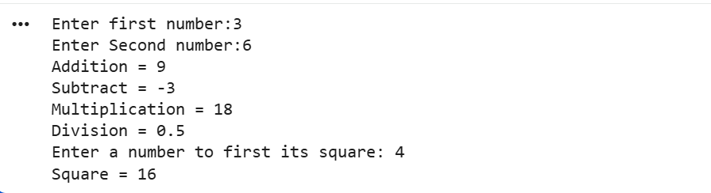

List and Dictionary:

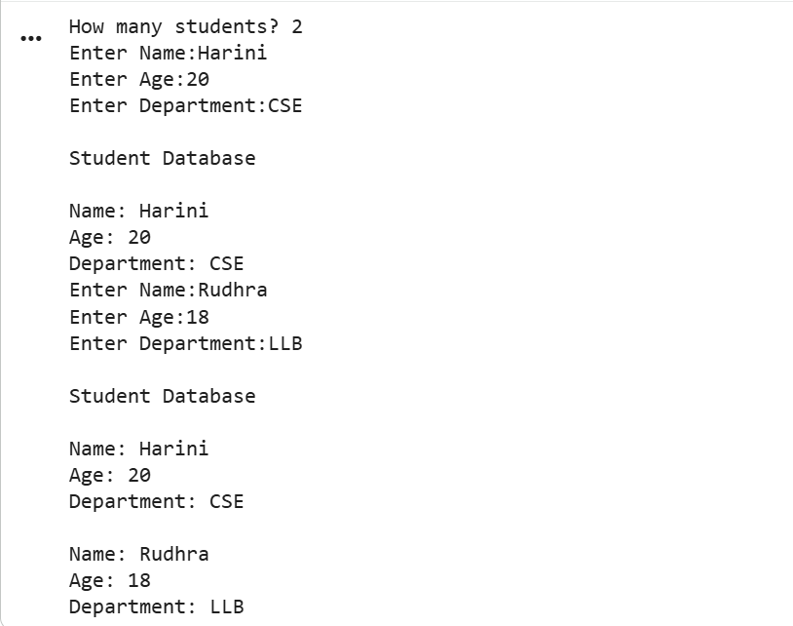

File Handling:

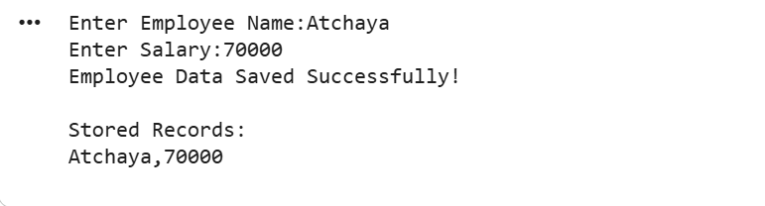

Employee Record Management System:

